1. **User Registration:**

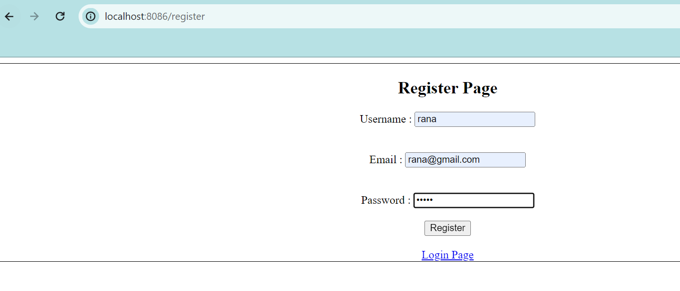

1. **Login Page:**

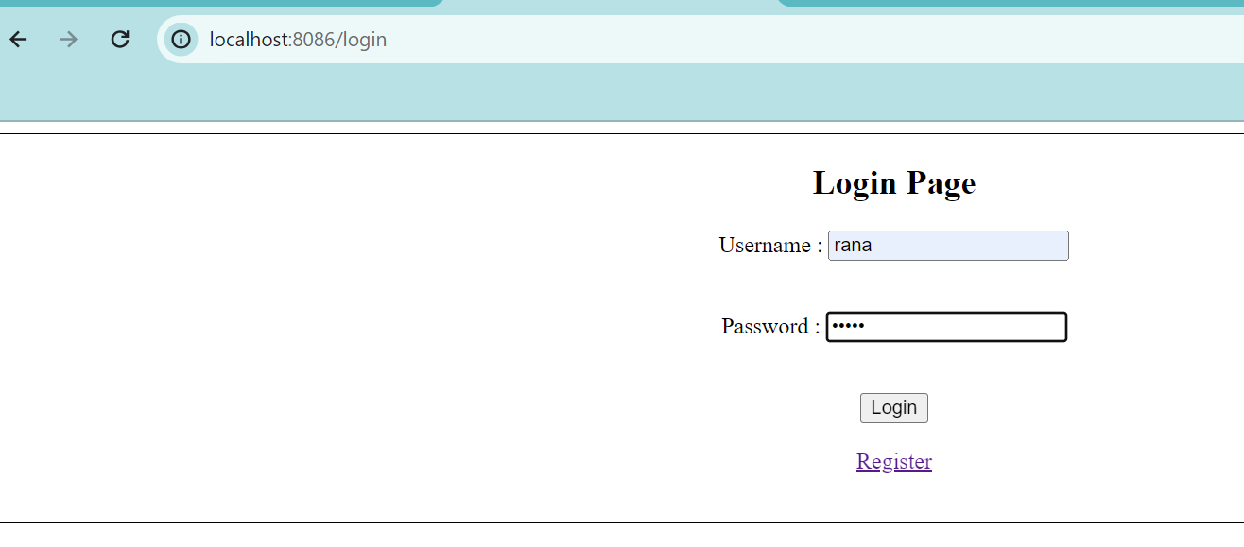

1. **Home page:**

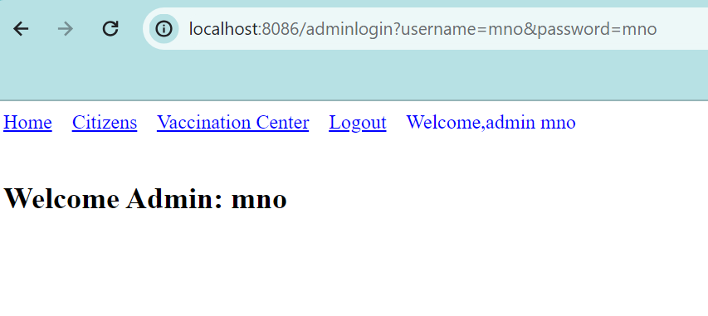

1. **Vaccination Center:**

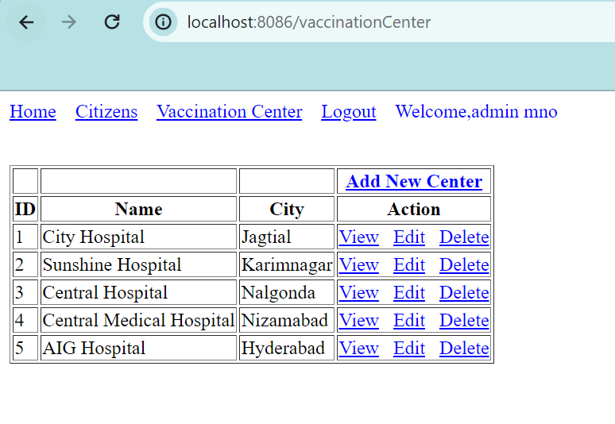

**5 .Add a new Vaccination Center:**

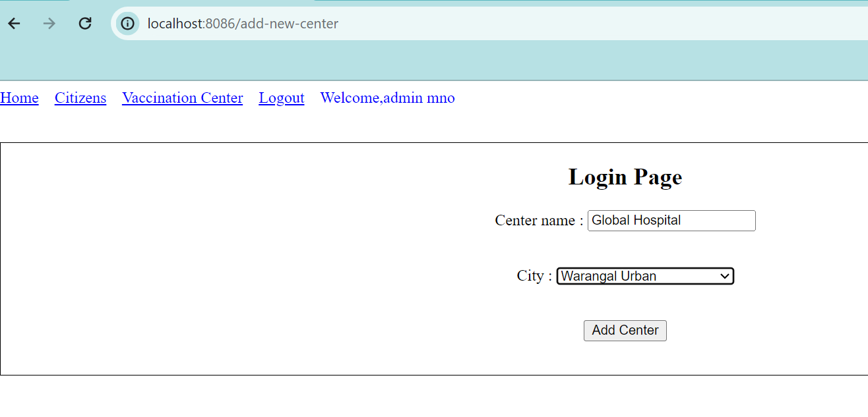

1. **Viewing Citizens:**

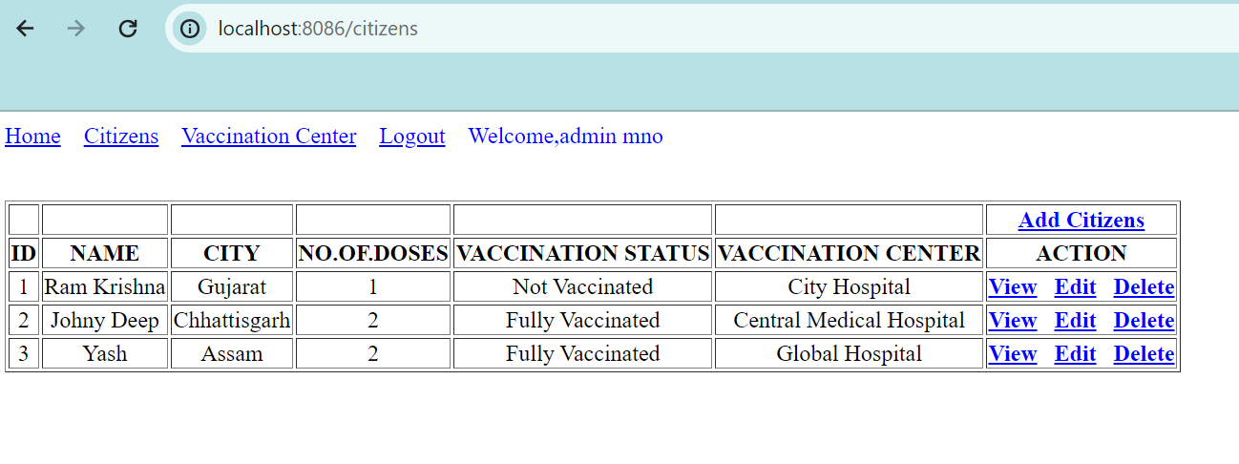

1. **Adding of citizens:**

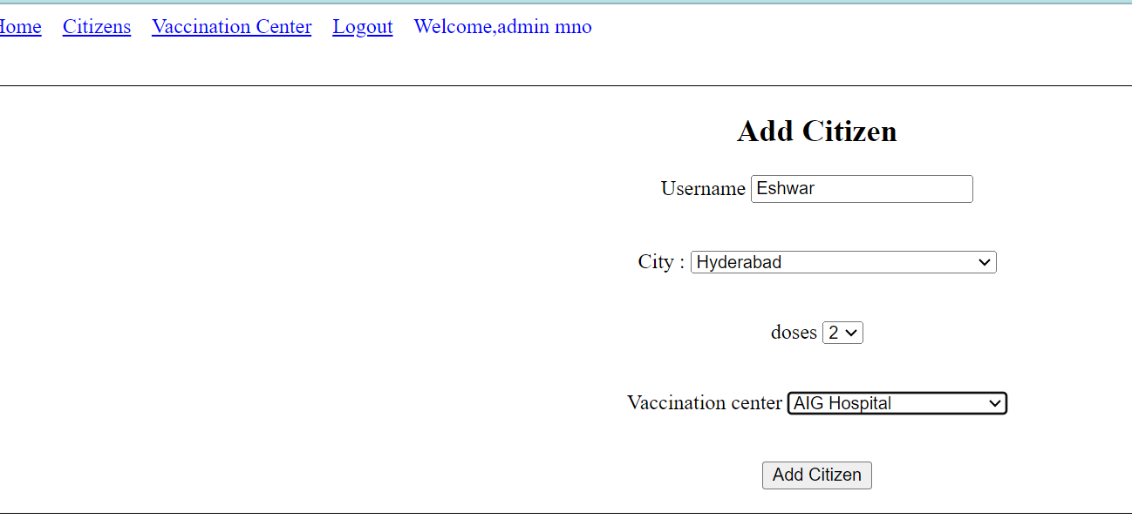

1. **After Adding Citizen:**

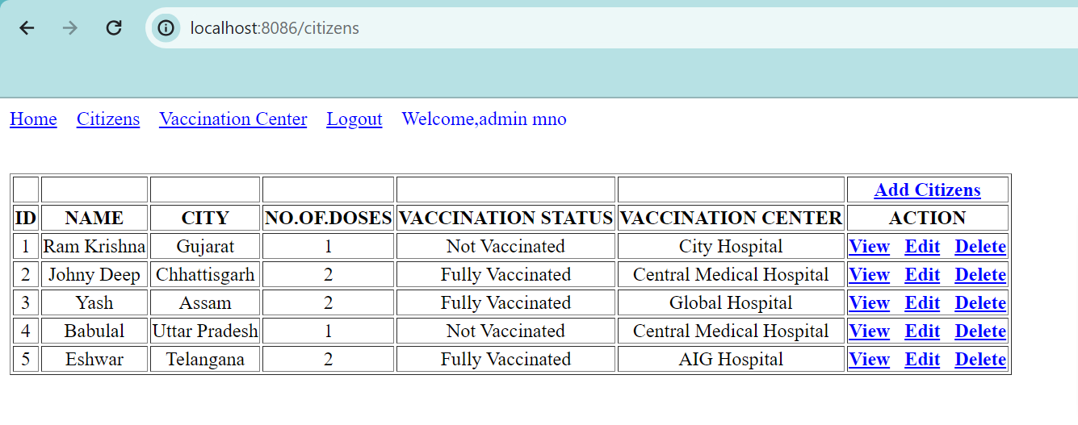

1. **Viewing of particular Citizen:**

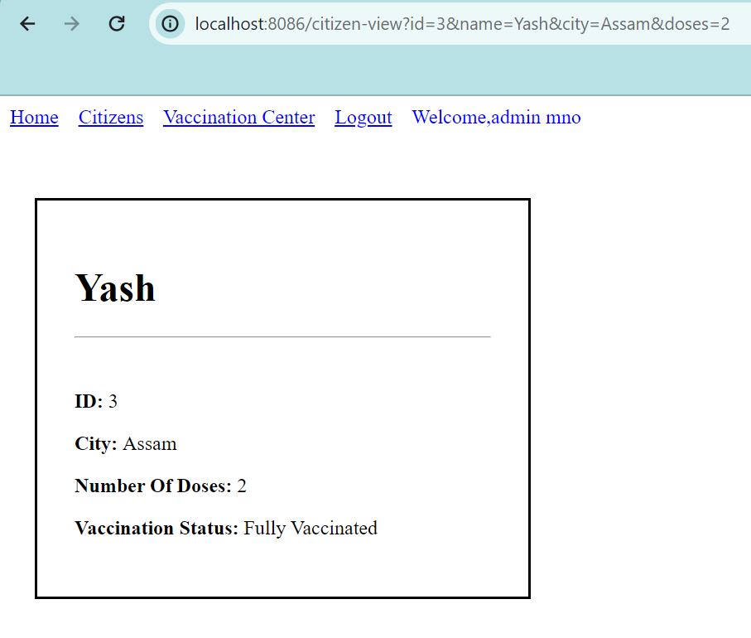

1. **Editing of Citizen Information:**

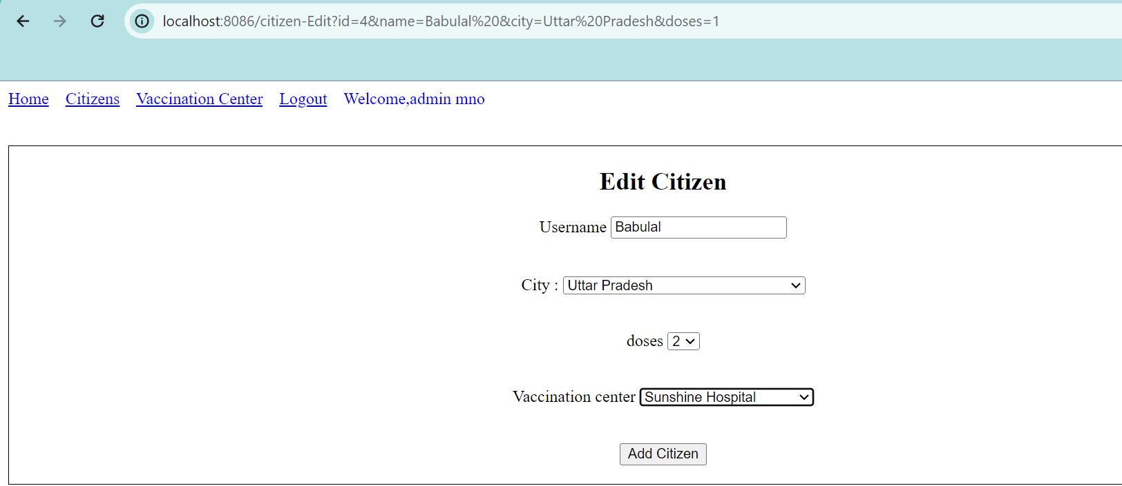

1. **After editing viewing of citizens:**

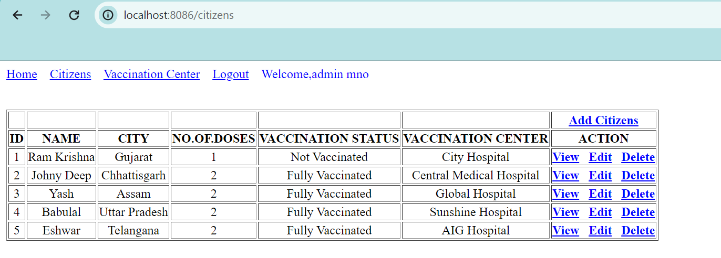

1. **After Deleting of citizen record:(viewing list):**

